营口大石桥经济开发区

Yingkou Dashiqiao Economic Development Zone

基本情况
The basic information

营口大石桥经济开发区始建于2001年，2004年晋升为省级开发区，2010年被省政府批准为辽宁沿海经济带重点支持区域，2015年被工信部评为国家新型工业化产业示范基地，2019年被商务部认定为国家级外贸转型升级基地，规划总面积17.85平方公里。
Yingkou Dashiqiao Economic Development Zone was founded in 2001 and promoted to provincial level in 2004. In 2010, it was approved as the key support area of Liaoning Coastal Economic Zone by the provincial government. In 2015, it was rated as the National New Industrialization Demonstration Base by the Ministry of Industry and Information Technology. The total planning area is 17.85 square kilometers.

开发区区位优势明显，地处于地处辽宁沿海经济带和辽宁中部城市群交叉点，营口沿海经济区30分钟经济圈内；开发区科研基础雄，已与辽宁非金属矿工业协会、辽宁科技大学、沈阳工业大学等科研院所达成战略合作，建立“政产学研”合作平台，区内有营口菱镁化工院士工作站以及辽宁津大、营口东邦2个博士后科研工作站；开发区基础设施完善，已建成15条主次干道，形成了“四纵三横”的 400 米间距路网格局，给水、通讯等综合管网全域覆盖，项目区基本达到 “七通一平”。
The development zone has obvious geographical advantages. It is located in the Yingkou Coastal Economic Zone 30 minutes economic circle, which is the intersection point of Liaoning Coastal Economic Zone and central Liaoning City Group. The development zone has established strategic cooperation with Liaoning Nonmetallic Mineral Industry Association, Liaoning University of Science and Technology, Shenyang University of Technology and other scientific research institutes. The cooperation platform of "government, industry, education and research" has been established. In the zone, there are Yingkou Magnesite Chemical Academician Workstation, Liaoning Jinda and Liaoning Yingkou Dongbang post-doctoral research workstations. The development zone has perfect infrastructure, with 15 main and secondary roads built, forming a 400-meter road network with "four vertical and three horizontal". The comprehensive pipe network for water supply and communication covers the whole region, and the project area has basically reached "seven connections and one level".

产业发展
The industrial development

开发区现已形成了以高端镁质产业、有色金属精深加工产业、装备制造业、再生资源、精细化工的集群发展。已入驻企业164家，规模以上企业46家，国家高新技术企业17家，新三板上市企业3家。
The development zone has formed a cluster development of high-end magnesium industry, non-ferrous metal deep processing industry, equipment manufacturing industry, renewable resources, fine chemical industry. There are 164 registered enterprises, 46 enterprises above designated size, 17 national high-tech enterprises and 3 listed enterprises on the New Third Board.

合作意向
The cooperation intention

开发区依托中国“镁都”产业基础，改造升级“老字号”，寻求高端镁质产业升级；深度开发“原字号”，寻求有色金属精深加工产业和新材料产业延链、补链；培育壮大“新字号”，寻求配套地区固废和危废处置、资源再生，构建绿色循环经济产业。
Relying on the industrial foundation of China's "Magnesium Capital", the development zone will transform and upgrade the "time-honored brand" to seek high-end magnesium industry upgrading. Deeper development of the "original name", seeking the non-ferrous metal deep processing industry and new material industry extension chain, supplementary chain. Cultivate and expand the "new brand", seek supporting areas solid waste and hazardous waste disposal, resource regeneration, and build a green circular economy industry.

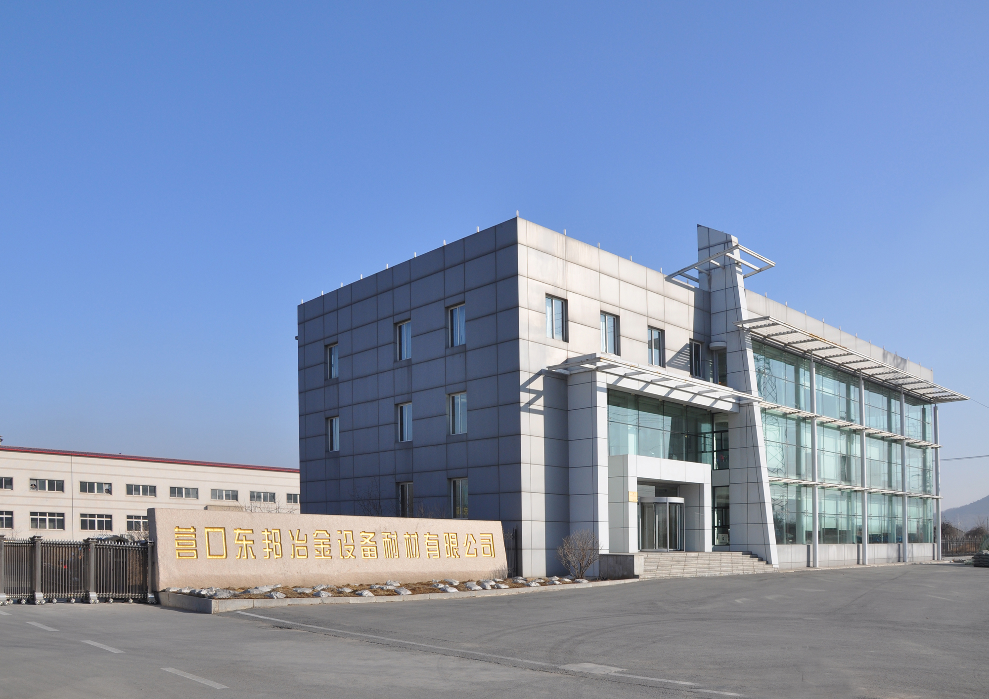
重点企业
Key enterprises
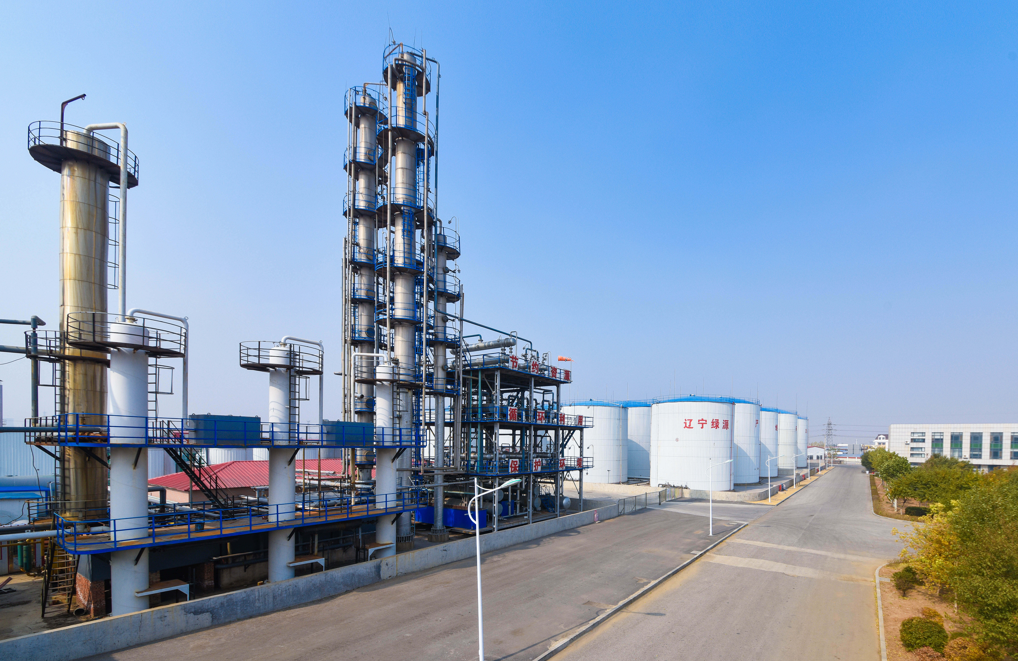
垃圾焚烧设备
Waste incineration equipment

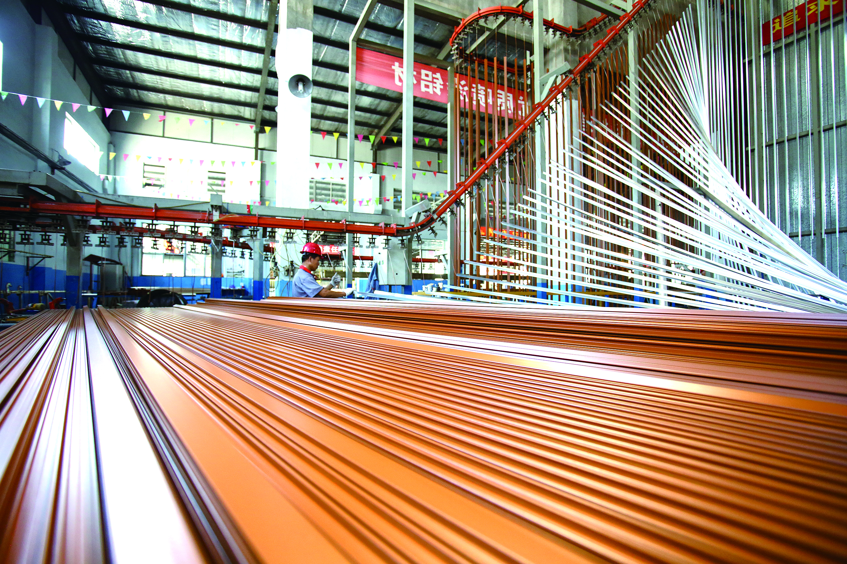
铝合金喷涂生产线
Aluminum alloy spraying production line
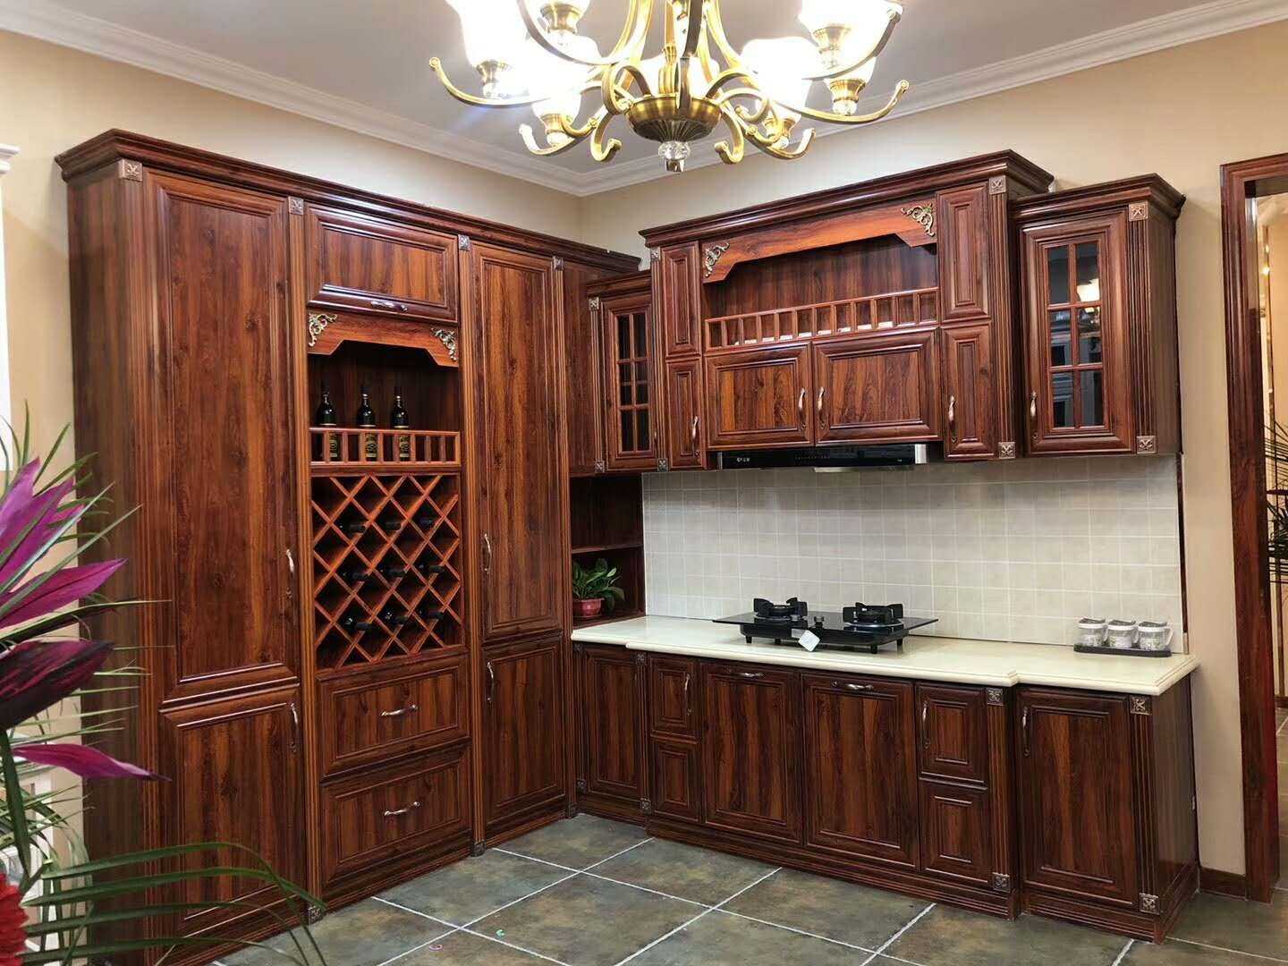

全铝家居
All aouminum furniture

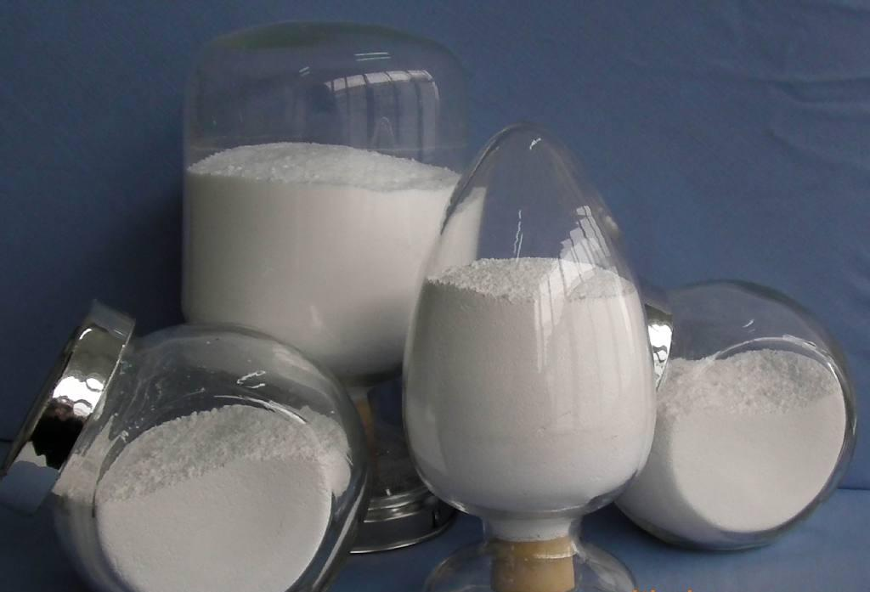
镁 粉
Magnesium Powder

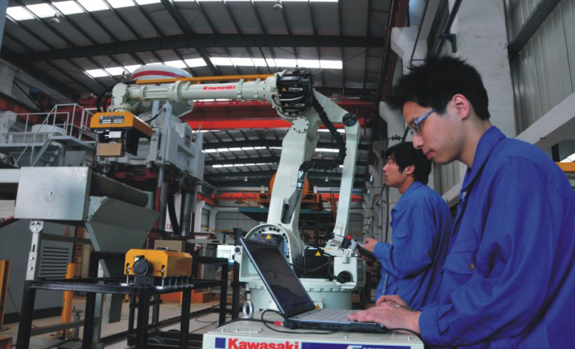
智能机器人
Intelligent robot

联系人：金刚
Contacts: Jin Gang
联系电话：0417-5895367
Contact number : 0417-5895367
邮箱： kfq5895562@163.com
Mailbox: kfq5895562@163.com

